University of Science and Technology
- Wrocław-



LABORATORY 12: UTILIZING SOFTWARE FOR RISK MANAGEMENT

SUPPORT FOR IT PROJECT MANAGEMENT
2025/2026
Teacher: Piotr Zabawa
Student: Álvaro Puebla Ruisánchez 293867

Table of Contents
Table of Contents 2
1. Software Overview 3
1.1 Name and Purpose 3
1.2 Key Functionality 3
1.3 Why Google Sheets Was Selected 3
2. Performed Tasks 4
2.1 Task 1 - Initialization and Data Preparation 4
2.2 Task 2 - Risk Identification and Assessment 5
2.3 Task 3 - Risk Matrix Visualization and Interpretation 6
3. Summary 7
3.1 Software Suitability Assessment 7
3.2 Evaluation of Software Functionality 7
3.3 User Interface Evaluation 7
3.4 Evaluation of Other Software Attributes 7

1. Software Overview

1.1 Name and Purpose
The software utilized for this laboratory session is Google Sheets, a web-based collaborative spreadsheet platform developed by Google LLC. Its primary purpose in the context of IT project management is to serve as a versatile environment for building a Central Risk Register and performing qualitative risk analysis.

1.2 Key Functionality
Google Sheets provides essential risk management capabilities through its calculation and formatting engines, including automated risk intake via forms, formulas for probability and impact scoring, and conditional formatting to create visual risk matrices. It supports the creation of risk titles, categorization, ownership assignment, and the development of dashboards for high-priority risk monitoring.

1.3 Why Google Sheets Was Selected
Google Sheets was selected for the laboratory exercise because it provides free access without the need for complex demo requests, making it immediately accessible for students. Furthermore, it offers a familiar interface that allows students to focus on the core concepts of risk registers and 5x5 matrices rather than learning a specialized UI, while still being powerful enough to handle automated scoring and data visualization.

2. Performed Tasks

2.1 Task 1 - Initialization and Data Preparation
Task description:
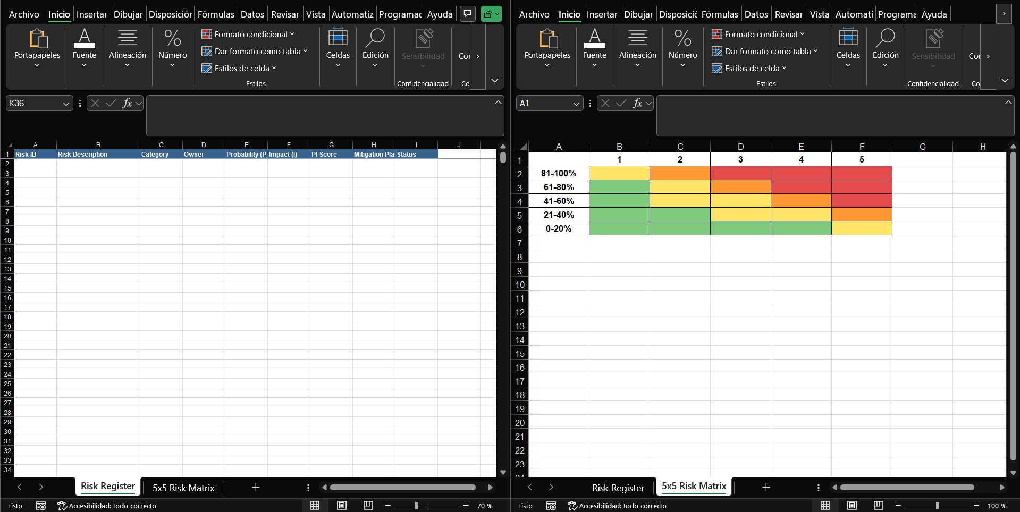
The initial phase involved preparing the environment by navigating to a new spreadsheet and importing the provided external data file titled "RiskTemplate.xlsx". After importing, the workbook structure was examined to identify two primary sheets: the "Risk Register" for data entry and the "5x5 Risk Matrix" for visualization. To ensure a clean workspace for the exercise, all existing sample risks within the template were deleted to make room for new project-specific data. [Figure 1]

Figure 1. Initial view of the imported RiskTemplate.xlsx showing the empty Risk Register structure.

2.2 Task 2 - Risk Identification and Assessment
Task description:
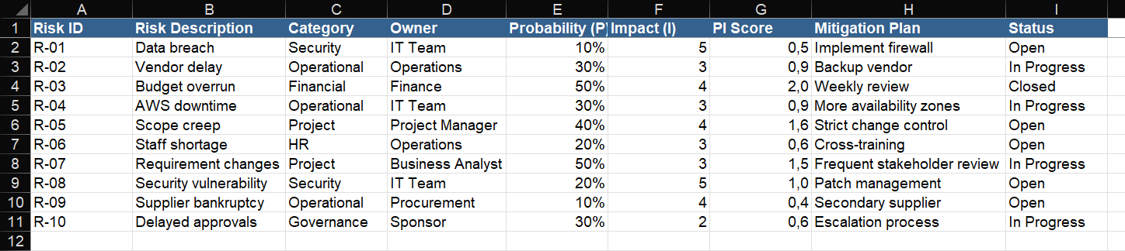
During this task, 10 unique project risks were identified and documented within the Central Risk Register. For each entry, specific parameters were assigned, most notably the Probability (likelihood of occurrence) and Impact (severity of the effect). These values were entered into the designated columns to allow the spreadsheet's formulas to calculate the qualitative risk score, effectively ranking the exposure for each identified threat. [Figure 2]

Figure 2. The Risk Register populated with 10 identified risks and their corresponding probability and impact scores.

2.3 Task 3 - Risk Matrix Visualization and Interpretation
Task description:
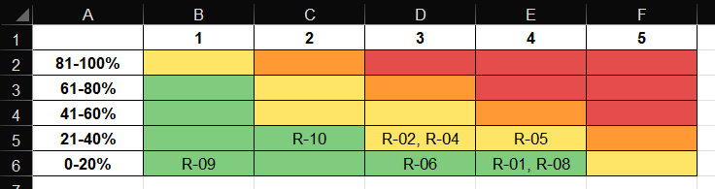
The final task involved switching to the "5x5 Risk Matrix" sheet to observe how the previously entered data was automatically mapped onto a color-coded grid. The matrix visualizes risks by placing their identifiers (e.g., R-01, R-02) into cells corresponding to their P/I scores, ranging from 0-20% to 81-100%. This visualization was interpreted to prioritize risks; for example, risks appearing in the red and orange zones represent high-priority threats requiring immediate mitigation, while those in the green zones represent low-level exposures. [Figure 3]

Figure 3. The 5x5 Risk Matrix displaying the distribution of risks across the color-coded priority zones.
This matrix shows that the highest risks are concentrated in the lower probability bands, especially where impact is high. The main hotspots are R-01 and R-08 in the 0-20% / 4-5 area, plus R-05 in 21-40% / 4, which means these risks deserve priority attention because their impact is strong even if likelihood is lower.
What the matrix says
- R-01 and R-08 are the most critical from a severity standpoint because they sit in high-impact cells.
- R-05 is also important because it combines moderate probability with high impact.
- R-02, R-04, R-06, R-09, and R-10 are lower-priority than those above, but still need monitoring.
Overall interpretation
- There are no risks in the 41-60%, 61-80%, or 81-100% probability bands, so none of the risks are highly likely.
- The matrix suggests the portfolio is not dominated by frequent risks, but by a few serious ones.
- In practice, you would focus mitigation on R-01, R-08, and R-05 first, then track the others with lighter controls

3. Summary

3.1 Software Suitability Assessment
Google Sheets is highly suitable for small to medium-scale IT project risk management, particularly for teams requiring low transition friction and high collaboration. While it lacks the native "risk engine" of enterprise tools like Active Risk Manager, it effectively serves as a single source of truth for tracking and prioritizations when structured correctly.

3.2 Evaluation of Software Functionality
The functionality is "medium" compared to specialized tools, as most features like risk matrices and automated alerts are "configured" or "formula-driven" rather than "native". However, its ability to handle automated intake through forms and complex conditional formatting makes it a robust tool for qualitative assessments.

3.3 User Interface Evaluation
The user interface is excellent in terms of familiarity and accessibility, as most students and professionals are already proficient in spreadsheet navigation. The web-based nature allows for real-time multi-user editing, which is a significant advantage over standalone desktop applications like RiskyProject Professional.

3.4 Evaluation of Other Software Attributes
A major advantage is the cost-effectiveness, ranging from a rich free version to affordable business tiers. A notable limitation is the lack of native quantitative analysis (like Monte Carlo simulations) found in tools like Safran Risk Manager, meaning advanced numerical modeling requires manual formula building or external add-ons.

